Gene Regulation

Assessment Statements
- Describe what housekeeping genes are
- Outline the function and structure of an operon
- Explain how gene regulation at the lac operon and the trp operon works

How and why genes are regulated
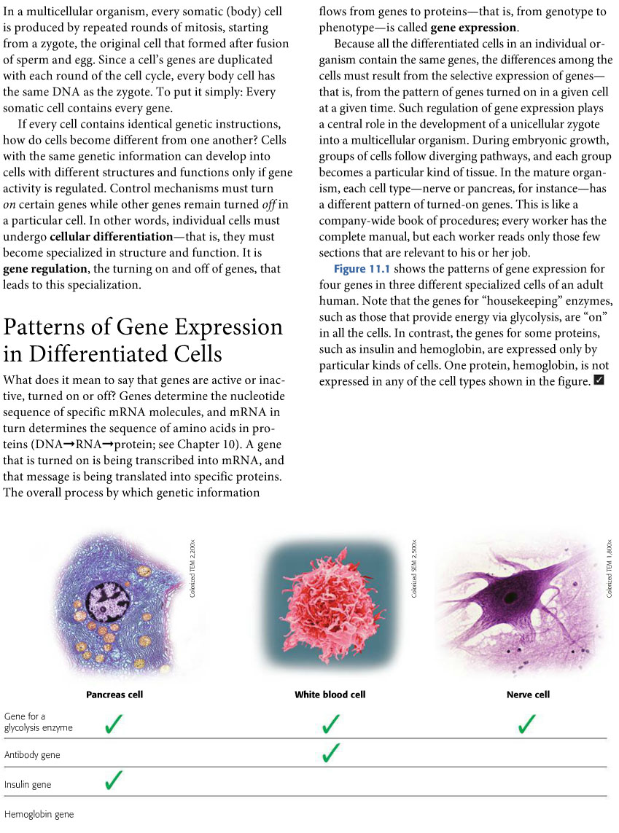 (Simon, 2013)
State further examples for housekeeping genes: These are genes that are aktive in all the cell types

The bacterial operon
Some gene products have to work together to fulfil a function (e.g. sugar digestion or amino acid production). In bacteria, these genes are organised in an operon. If the operon gets activated, all essential proteins for a certain function are produced together.

Promoter:
Here, the RNA polymerase binds

Operator:
Can be blocked by a repressor protein to avoid the RNA polymerase to bind to the promoter.

Structural genes:
Genes that are collectively regulated by the operon. Usually, they are enzymes manufacturing something the cell needs.

Transcription is working:
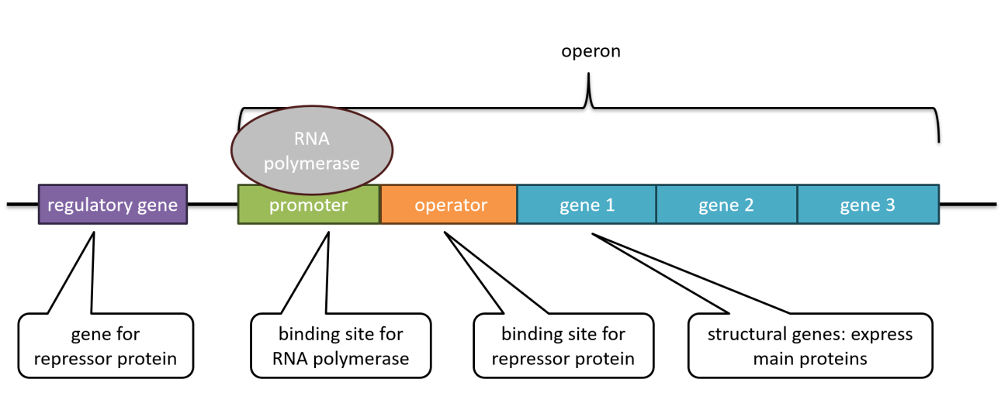

Transcription is blocked:
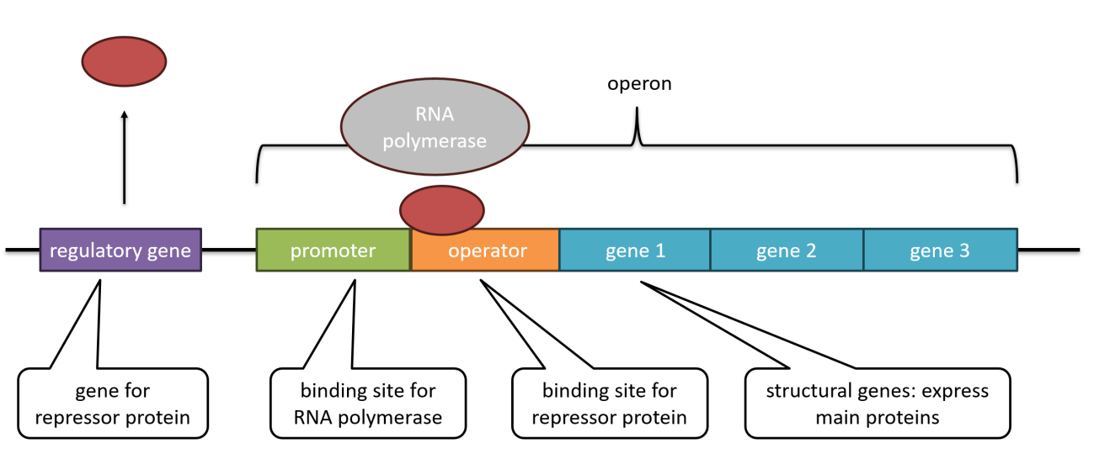

Eukaryotic gene regulation
In contrast to bacteria, eukaryotic genes normally are not organised in operons. Each individual gene has its own promoter, and further away enhancers or silencers. Here, various proteins – transcription factors – bind and turn transcription on or off.
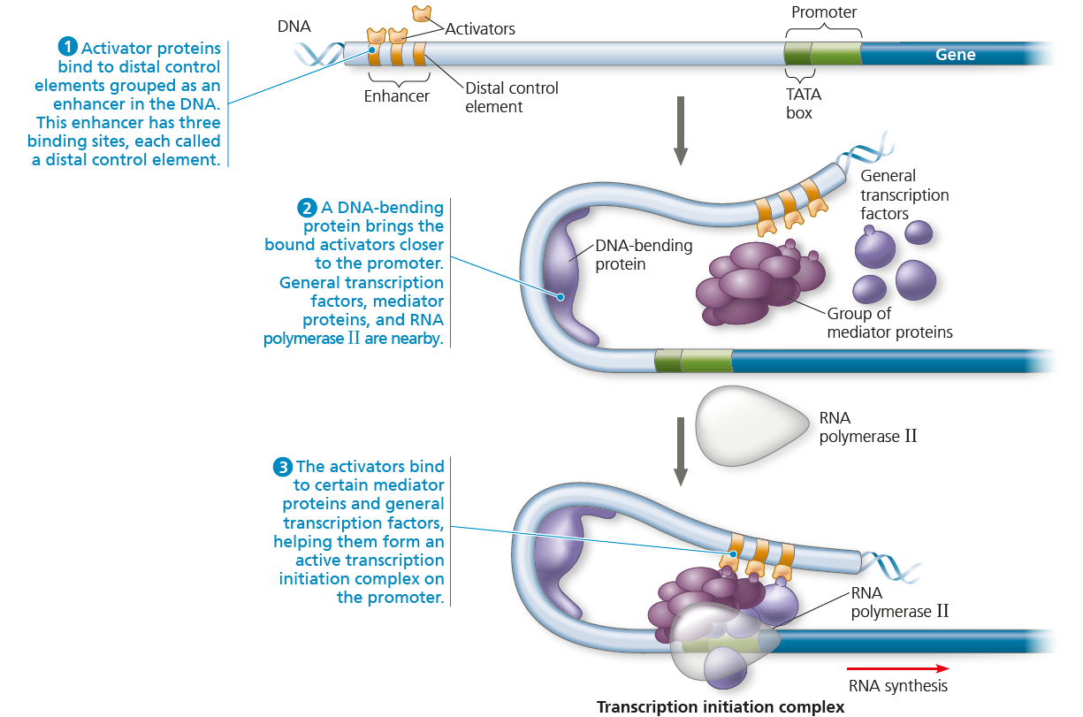

Initiation of transcription is the most important step in gene regulation. However, it is also possible to inactivate DNA by dense DNA packing, mRNA breakdown (destruction of mRNA before translation) or with the help of small single-stranded RNA molecules which bind to and block the mRNA molecule.

Gene regulation in bacteria

lac operon – gene expression induced by the substrate
- Operon: genes for a certain function which are controlled the same way
- Promoter: binding site for RNA polymerase
- Operator: switch to turn gene expression on or off
- Repressor: protein expressed by the regulatory gene; binds to operator; can be active or inactive

inactive: active:
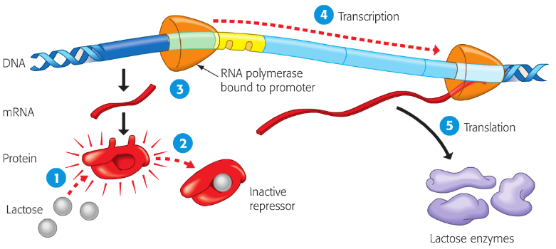
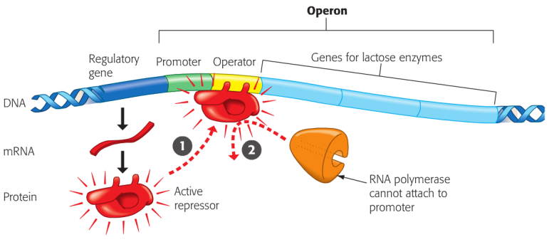

What is produced in this example? What is it used for in bacteria?

What has to be present in order to start gene expression?

trp operon – gene expression inhibited by the substrate
- Operon: genes for a certain function which are controlled the same way
- Promoter: binding site for RNA polymerase
- Operator: switch to turn gene expression on or off
- Repressor: protein expressed by the regulatory gene; binds to operator; can be active or inactive
Tryptophan (trp) is an amino acid produced by bacteria.

active:

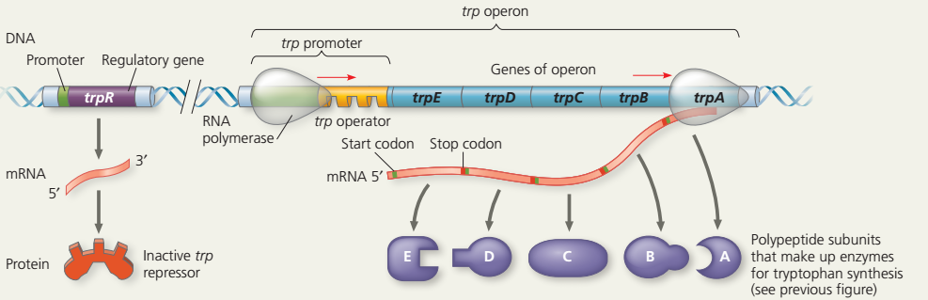

inactive:
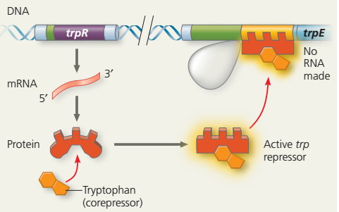
What is produced in this example? What is it used for in bacteria?
The amino acid Tryptophan is produced.

What has to be present in order to start gene expression?
No trp repressor can be bound to a trp operator, which happens when there is no tryptophan.

Used Tools and References
- https://ib.bioninja.com.au/higher-level/topic-7-nucleic-acids/72-transcription-and-gene/operons.html
- Reece, J. B. et al. (2018). Campbell Biology. (11th edition). Pearson Education.
- Simon, E. J., Reece, J. B., Dickey, J. L. (2013). Essential Biology with Physiology. (4th edition). Pearson Education.

CC BY 4.0 DEED for contents created by Daniel Margadant
For other sources (e.g., figures) please consider © of corresponding reference

